THE JANE STREET DICE GAME
TITLE PAGE

Subject: Foundation of programming

Submitted By:
- Ayush Deshpande– 1262253095
- Mohit Wayal– 1262252871
- Soham Dhole– 1262250230
- Pranav Khating– 1262253914

Project Guide:
Dr. Anushri Kulkarni

Institution Name:
MIT-WPU

TABLE OF CONTENTS
- Title Page …….………………………………………………1
- Acknowledgement ....…….…………………………………………3
- 1. INTRODUCTION ..………………………………………………………………4
- 2. PROBLEM STATEMENT ………………………………..………………………………4
- 3. OBJECTIVES …………………………………………………………………4
- 4. PROJECT DESCRIPTION …………………………………………………………………5
- 5. SYSTEM DESIGN AND METHODOLOGY ……………………………………………………6
  - 5.1 Overall Design Approach ………………………………………………….6
  - 5.2 Board Representation ………………………………………………….6
  - 5.3 Algorithms ………………………………………………….6
- 6.CODE …………………………………………………7
- 7.Sample Output ………………………………………………..10
- 8. RESULTS AND DISCUSSION ………………………………………………..11
- 9. CONCLUSION ………………………………………………..11
- 10. FUTURE SCOPE ………………………………………………..11
- 11. REFERENCES ………………………………………………..11

Acknowledgement
We would like to express our sincere gratitude to our respected project guide for their continuous guidance, encouragement, and valuable suggestions throughout the development of this project. Their support helped us understand the practical implementation of programming concepts beyond theoretical learning.
We also thank the faculty members of the Computer Science department for providing us with the necessary knowledge and technical foundation required to complete this project successfully. The concepts taught in the Foundations of Programming course were essential in designing and implementing this system.
We are equally thankful to our teammates for their cooperation, teamwork, and dedication during the project development process. This project would not have been possible without collaborative effort and effective communication among team members.

1. Introduction
The “Take or Reroll – Risky Multiplier Game” is a console-based game developed using the C programming language. The game is designed to test a player’s decision-making ability under uncertainty. It combines randomness with strategic thinking, where the player must decide whether to accept the current score or take a risk for a potentially higher score.
The project demonstrates fundamental programming concepts such as loops, conditional statements, functions, and random number generation. It also introduces a basic form of game logic and user interaction through a command-line interface.
2. PROBLEM STATEMENT
The problem addressed in this project is to design a simple interactive game that incorporates randomness and decision-making. The challenge is to create a system where the player balances risk and reward to maximize their final score.
The player must decide whether to accept a current score or reroll for a better outcome, knowing that the number of attempts is limited. The goal is to achieve a score as close as possible to 4000.
3. OBJECTIVES
- To develop an interactive console-based game using C
- To implement random number generation using rand()
- To apply decision-making logic using conditional statements
- To demonstrate modular programming using functions
- To enhance user engagement through scoring and feedback system

4. Take or Reroll – Risky Multiplier Game
This project is a console-based game developed using the C programming language. The main objective of the game is to achieve a score as close as possible to 4000 by making strategic decisions between taking a current score or rerolling for a better one. The project demonstrates the use of fundamental programming concepts such as loops, functions, conditional statements, and random number generation.
The game operates on a simple yet engaging logic. In each attempt, the system generates a random number between 1 and 20 using the rand() function. The player is given a maximum of 20 attempts. For every roll, a potential score is calculated using the formula:
Final Score = 10 × rolled number × attempt number
After each roll, the player must decide whether to "Take" the current score or "Reroll" to try for a better number. This introduces a risk-reward mechanism, where early attempts have lower multipliers but later attempts increase the score significantly. However, waiting too long may result in a poor roll. On the final attempt, the player is forced to accept the result.
The program uses multiple functions to maintain modularity and readability. The show_welcome() function displays game instructions, while get_choice() handles user input for decision-making. The play_game() function controls the main game loop, and print_tier() evaluates the final score and assigns a performance level based on how close the score is to 4000. This tier system enhances user engagement by providing feedback such as "Perfect", "Outstanding", or "Try Again".
Basic data structures such as integer variables and character arrays are used for storing game data and user input. The srand(time(NULL)) function ensures that different random values are generated each time the program runs. Input validation is also implemented to handle incorrect user entries.
The game provides an interactive command-line interface, making it user-friendly and easy to understand. It also includes a replay option, allowing users to play multiple rounds without restarting the program.
This project effectively demonstrates the practical application of C programming concepts in game development. It improves logical thinking and decision-making skills while reinforcing concepts like control flow and randomness. The simplicity of the design makes it suitable for beginners, while the strategy element keeps it engaging.
Future enhancements can include adding a graphical user interface, maintaining a high-score leaderboard, introducing multiplayer functionality, and integrating sound effects for a better user experience.
In conclusion, the "Take or Reroll" game is a well-structured and interactive project that successfully combines programming fundamentals with strategic gameplay, making it both educational and entertaining.
5. SYSTEM DESIGN AND METHODOLOGY
5.1 Overall Design Approach
The program follows a procedural programming approach. The game flow is controlled using loops and functions. The system repeatedly generates random values and prompts the user for input until a termination condition is reached.
5.2 Board Representation
There is no graphical board in this project. The game state is represented using variables:
- attempts → number of tries
- roll → random number generated
- final_score → calculated score
5.3 Algorithms
- Start the program
- Initialize random seed using srand()
- Repeat for maximum 20 attempts:
  - Generate random number (1–20)
  - Calculate potential score
  - Ask user to take or reroll
- If user selects take → end game
- If attempts reach 20 → force take
- Display final score and performance tier
- Ask user to play again

6.CODE
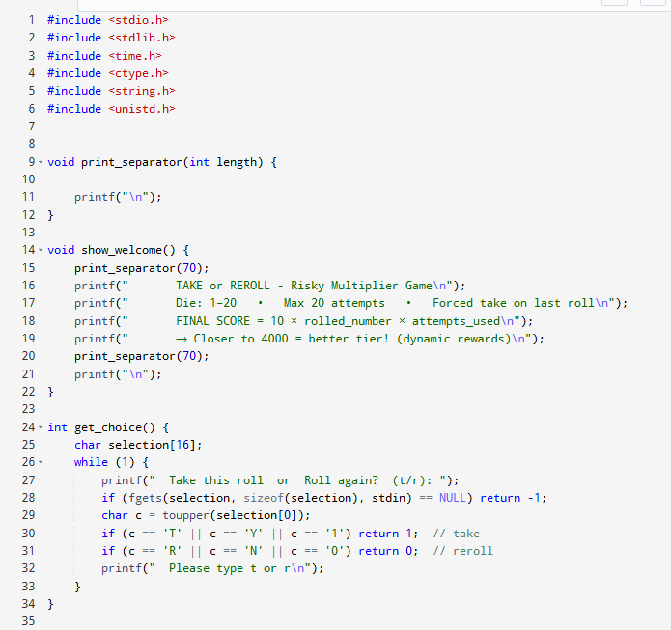
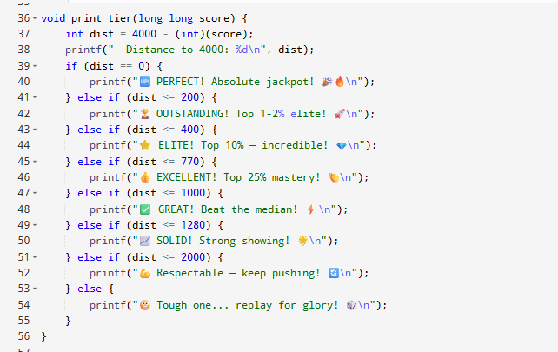
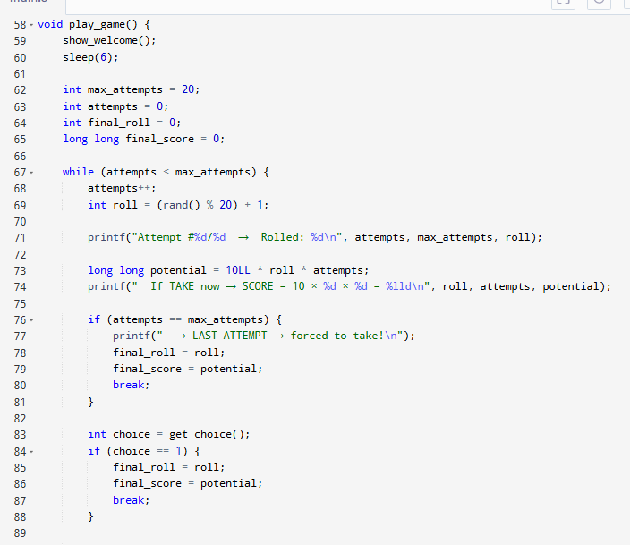
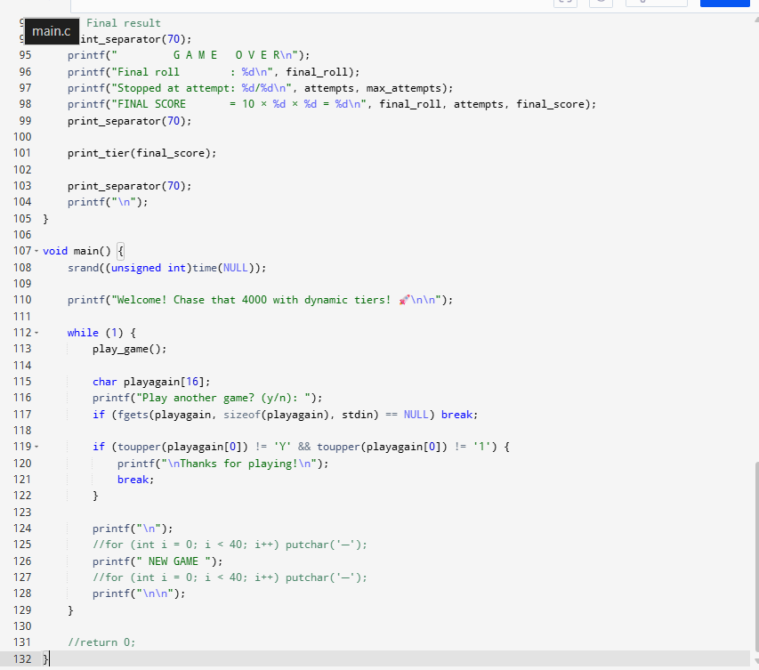
7.Sample Output
Attempt #1/20 → Rolled: 12
If TAKE → SCORE = 120
User chooses: Reroll
Attempt #2/20 → Rolled: 18
If TAKE → SCORE = 360
User chooses: Take
GAME OVER
Final Score = 360
Tier: GREAT!

8. RESULTS AND DISCUSSION
The program successfully generates random values and allows user interaction. The scoring system effectively creates a balance between risk and reward.
Users tend to either play safely or take risks depending on their strategy. The tier system adds motivation and improves engagement.

9.Conclusion
The project demonstrates the application of C programming concepts in game development. It successfully integrates randomness, logic, and user interaction. The game is simple yet engaging and helps improve logical thinking.
10. FUTURE SCOPE
- Add graphical user interface (GUI)
- Implement leaderboard system
- Add multiplayer functionality
- Include sound effects and animations
- Improve scoring algorithm
11. REFERENCES
- C Programming Language by Brian W. Kernighan & Dennis Ritchie
- GeeksforGeeks – C Programming Tutorials
- TutorialsPoint – C Standard Library
- Online compiler documentation

